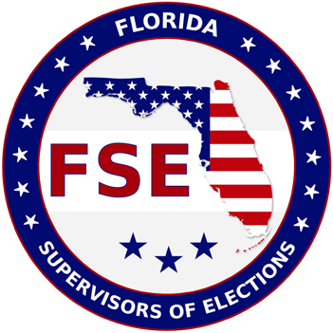
GUIDELINES FOR THE
FLORIDA SUPERVISORS OF ELECTIONS SCHOLARSHIP - STUDENT ELIGIBILITY

STUDENT ELIGIBILITY – To be eligible for the FSE Scholarship the student applicant shall:

1. Be a Political Science/Public Administration/Business Administration or Journalism/Mass Communication major.
2. Be a citizen of the United States.
3. Have been a resident of Florida for two years preceding the academic year for which an application is made.
4. Be enrolled or accepted as a full-time student in a senior college or university in Florida. No post-graduate or second-degree students.
5. Be at least a junior in college, or have enough credits for enrollment as a junior prior to the application deadline.
6. Submit two current letters of recommendation: one from the college or university last attended or graduated from; and one from a citizen of good standing in the community.
7. Submit a resume of your high school and/or college activities, as well as, what you have done for your community.
8. Demonstrate a financial need and furnish a financial statement, which shows what your own contribution is to your educational expenses. (Student does not have to submit an official form, can just send a statement of their financial need.)
9. Have maintained a “C” average or above for the previous school year.
10. Be available for an interview by the Supervisor of Elections in the county where you are registered to vote.
11. BE REGISTERED TO VOTE. (Written verification required by Supervisor submitting application where you are registered to vote.)

ELIGIBLE INSTITUTION – Scholarship must be given to student attending a Florida university or college, which is accredited by the Southern Association of Colleges and Schools.

STIPULATION – The scholarship check will be made payable to the winning applicant AND to the school where they will be attending.

STUDENT:

1. Must apply in accordance with all eligibility requirements. (Failure to do so could result in non-consideration). 2. Must continue to meet all initial eligibility requirements.
3. Must maintain a “C” average or above.
4. Must remain in good standing at the institution.

APPLICATION:

1. Must be received by the Supervisor of Elections in the county that you are registered in by March 10, 2023.
2. Letters of recommendation MUST ACCOMPANY APPLICATION OR BE RECEIVED BY THE DEADLINE.

SELECTION – Each county’s Supervisor will review all applications received and select one finalist to be sent to the
FSE Scholarship Committee, along with a letter of recommendation for the applicant. The FSE Scholarship Committee will select FOUR winners ($1,200 each) from the finalists submitted by the Supervisors. A student who has received the scholarship award may make a second application the following year.

MAIL OR EMAIL TO: Osceola County
Supervisor of Elections
2509 E. Irlo Bronson Mem. Hwy.
Kissimmee, FL 34744
kari.ewalt@voteosceola.com

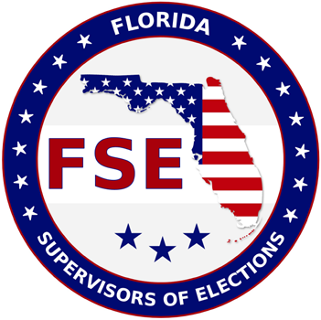
FLORIDA SUPERVISORS OF ELECTIONS

APPLICATION FOR SCHOLARSHIP

I am applying for the FSE Scholarship and

I am enrolled [ ] or I have been accepted [ ] at:

_____________________________________________________________________________________________

Name of College or University

1. Name (Mr., Mrs., Ms.): ____________________________________________________________________ Last First Middle
2. Permanent Address: ______________________________________________________________________ ______________________________________________________________________ ______________________________________________________________________
3. Phone Number (______) ___________________________________________________________ Area Code and Number
4. Email: ____________________________________________________________
5. Sex: M [ ] F [ ]

6. Date of Birth (Month / Day / Year): __________________________________________________________ 7. Social Security Number: ___________________________________________________________________ 8. Marital Status: Single [ ] Married [ ] Other [ ]: ____________________________________________
9. High School G.P.A.: ______________ College G.P.A.: __________________________________________ 10. Junior College/ College/ University from which you were graduated or will be graduated:
11. Current Grade Level Status for Undergraduate College: Junior _____ Senior _____

Filing this application does not imply that a scholarship will be awarded. It does place the applicant in line for consideration. Scholarship will be awarded only to the applicant who has been accepted at one of Florida’s universities or colleges.

If I accept this scholarship, it is understood that:

I will be a full-time student as defined by the Office of the Registrar I will be majoring in:
󠇋󠇋 Political Science/Public Administration/Business Administration
󠇋󠇋 Journalism/Mass Communication

_________________________________________

Signature of Applicant
_______________________________________

Date

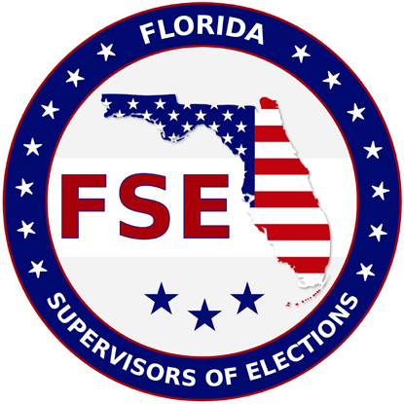
2023 FSE Scholarship

Applicant ______________________________

County ________________________________

Does student application meet the following requirements?

_____Yes _____ No

_____Yes _____ No

_____Yes _____ No

_____Yes _____ No

_____Yes _____ No

_____Yes _____ No

_____Yes _____ No

_____Yes _____ No
1. Registered voter having lived as a resident of Florida for the preceding two years. (Written verification by Supervisor of Elections submitting the application.)

2. Finished two years of college (junior college/ college/ university) or enough credits for enrollment as a junior before deadline

3. Currently accepted or enrolled as a full-time student in a college or a university in Florida

4. Political Science/Public Administration/Business Administration or Journalism/Mass Communication major

5. Maintain a “C” average or above for the previous year

6. Two letters of recommendation: one from college last attended or graduated from and one from a citizen of good standing in the community

7. Resume of high school and/or college activities, as well as community activities

8. Financial need information

